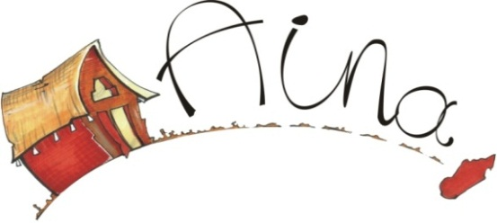

www.aina-madagascar.org

**AINA MADAGASCAR**

**CHARTER OF AINA MADAGASCAR TRAVELERS**

Solidarity Tourism is becoming a powerful force for creating more jobs, combating poverty and, simultaneously, protecting the natural and cultural environment, and above all promoting brotherhood.

In April 1995, a World Conference on Sustainable Tourism, held in Lanzarote and co-hosted by the World Tourism Organization, adopted a Charter asserting that tourism development should be based on criteria of sustainability: 'It must be ecologically sound in the long term, economically viable, as well as ethically and socially equitable for the local communities’.

The Charter of **AINA MADAGASCAR** travelers gives an opportunity for the people to share our aims to belong in our network, share the experience of our “outside the bow trip” and see if they are really suitable to our aims and co-exist with us.

**Article 01: nonprofit organization**

Travelers will be mindful that **AINA MADAGASCAR** is neither a profit organization nor professional firm, this is an organization that focuses on brotherhood, intercultural, and sharing experience, not a charity.

**Article 02: Guest and host**

Travelers will be considered as guests not tourists, the amount that travelers will pay directly to the family hosts will be considered as kind of contribution to the expenses not a fee in return for services.

**Article 03: Respect and cultural coexistence**

Two or more groups of culture and background are living together while respecting their differences. At the core of coexistence is the awareness that individuals and groups differ in numerous ways including class, ethnicity, religion, gender, and political inclination. By the way, **AINA MADAGASCAR**‘s travelers must avoid to refer exclusively into their own ideology, but to explore ways for community structures and systems to embody fairness, equity.

**Article 04 : North /South beyond wealth vision**

Financial and wealth are not only the core of relationships. The aim of the trip is first of all brotherhood from two cultures not only measured by material success; All from wealthy countries are not always supposed to be rich and all from poor countries are not always supposed to be poor.

**Article 05: Personal growth**

Our trip is also about self-discovery, making an adventure that your imagination is only the limit. This will adapt yourself to the reality of Human beings and make you stronger psychologically and emotionally